 | curriculum.newvisions.org/social-studies  Timothy Lent - tlent@newvisions.org  Kameelah Rasheed - krasheed@newvisions.org | 
Please Read: We encourage all teachers to modify the materials to meet the needs of their students. To create a version of this document that you can edit:  1. Make sure you are signed into a Google account when you are on the resource.  2. Go to the "File" pull down menu in the upper left hand corner and select "Make a Copy." This will give you a version of the document that you own and can modify. |  | 
Teacher Overview: How did the Ottoman Empire, as led by Suleiman the Magnificent, gain, consolidate, and maintain power?
Go directly to student-facing materials!

 | SQ 4. What was the Ottoman conquest of Constantinople? Why was the Ottoman conquest of Constantinople a turning point? | SQ 5. How did the Ottoman Empire, as led by Suleiman the Magnificent, gain, consolidate, and maintain power? | SQ 6. What do the Turkish Letters (1589) reveal about how outsiders viewed the Ottomans? | 

 | Unit Essential Question(s): How did the Ottoman Empire and Ming Dynasty gain, consolidate, and maintain power? | Link to Unit
Supporting Question(s):
- How did the Ottoman Empire, as led by Suleiman the Magnificent, gain, consolidate, and maintain power?
Objective(s):
- Describe how the Ottoman Empire, as led by Suleiman the Magnificent, gained, consolidated, and maintained power.

1. NYS Social Studies Framework:
Key Idea | Conceptual Understandings | Content Specifications
9.7 THE OTTOMAN EMPIRE AND THE MING DYNASTY PRE-1600: Islam, Neo-Confucianism, and Christianity each influenced the development of regions and shaped key centers of power in the world between 1368 and 1683. The Ottoman Empire and the Ming Dynasty were two powerful states, each with a view of itself and its place in the world.  (Standards: 2, 3, 4, 5; Themes: ID, MOV, GEO, SOC, GOV, EXCH) | 9.7b The dominant belief systems and the ethnic and religious compositions of the Ottoman Empire and the Ming Dynasty affected their social, political, and economic structures and organizations. | Students will analyze how the ethnic and religious compositions of the Ottoman Empire and the Ming Dynasty were reflected in their political and societal organizations.
2. Social Studies Practices
NYS Social Studies Practices | New Visions Student Social Studies Practices
Gathering, Using and Interpreting Evidence (A5, A7)  Chronological Reasoning and Causation (B1)  Comparison and Contextualization (C3, C5, C6)  Geographic Reasoning (D1, D2, D5) |    Predict Contextualize

3. Common Core
Reading | Writing | Speaking and Listening
Craft and Structure:  CCSS.ELA-LITERACY.RH.9-10.4: Determine the meaning of words and phrases as they are used in a text, including vocabulary describing political, social, or economic aspects of history/social science.  Integration of Knowledge and Ideas:  CCSS.ELA-LITERACY.RH.9-10.7: Integrate quantitative or technical analysis (e.g., charts, research data) with qualitative analysis in print or digital text. | Text Types & Purposes:  CCSS.ELA-LITERACY.WHST.9-10.1: Write arguments focused on discipline-specific content. | Comprehension and Collaboration:  CCSS.ELA-LITERACY.SL.9-10.1: Initiate and participate effectively in a range of collaborative discussions (one-on-one, in groups, and teacher-led) with diverse partners on grades 9-10 topics, texts, and issues, building on others' ideas and expressing their own clearly and persuasively.

Associated Classroom Posters
Student Social Studies Practices Poster

Objective: | How did the Ottoman Empire, as led by Suleiman the Magnificent, gain, consolidate, and maintain power?  - Describe how the Ottoman Empire, as led by Suleiman the Magnificent, gained, consolidated, and maintained power.
Introduction
➡ Directions: In the spaces below, write out at least two methods that empires you have already learned about used to gain, consolidate, and maintain their power.

GAIN  $$  Gaining power is the process of getting it and expanding it. | CONSOLIDATE  $$  $$  Consolidating power is the process of taking control from other people who also have power. | MAINTAIN  $$  $$  $$  $$  $$  $$  $$  $$  $$  Maintaining power is the process of keeping one’s power.
➡ Directions: Examine the map and make a prediction below.
Predict | 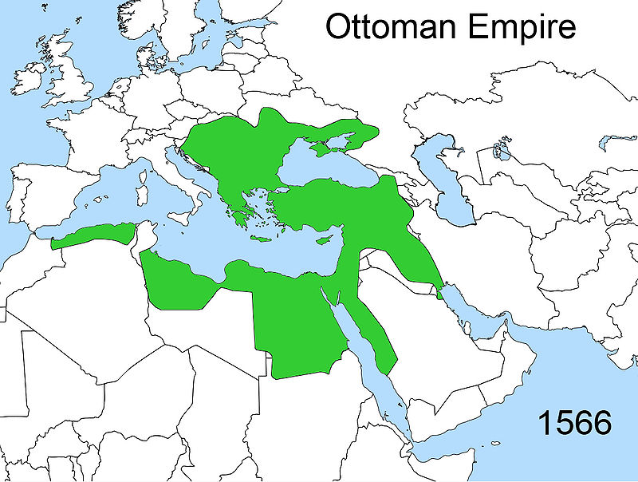  Map adapted from this image, which is is courtesy of Wikimedia Commons and is public domain. | At the height of its power, the Ottoman Empire under Suleiman (1520-1566) controlled a large territory in Europe, Africa, and Asia.  Make a Prediction: How do you think Suleiman was able to gain control of large territories across three continents?
➡ Directions: Read the excerpts below and respond to the questions.  Contextualize Suleiman the Magnificent was the sultan of the Ottoman Empire and Caliph of Islam from 1520 to 1566. Ottoman power reached its height and became a world power under his rule. His rule represented one of the most orderly periods of Ottoman history. While Suleiman was known as "the Magnificent" in the West, he was known as the "The Lawgiver" to his own Ottoman subjects. He was known as “The Lawgiver” because of how he ruled his empire:  - Enforced Shari'ah, or Sacred Islamic Law  - Created another legal code called Kanuns which covered criminal law, land tenure and taxation that lasted for over three hundred years  - Acted against corrupt officials, especially those who overtaxed the population  - Protected Jewish subjects from persecution  - Created schools for Muslim boys to learn grammar, philosophy, the sciences, etc.  - Built strong fortresses to defend the places he conquered and adorned the cities with mosques, bridges, aqueducts, and other public works  - Transformed the previously Christian Byzantine city of Constantinople into Istanbul, the Islamic center of the Ottoman Empire  References:  “Suleiman the Magnificent.” New World Encyclopedia. Web. 17 July 2010; Yalman, Suzan & Linda Komarof. “The Age of Suleyman ‘the Magnificent’ (r. 1520-1566);” Heilbrunn Timeline of Art History. The Met. Web. 17 July 2010; Parry, V.J. “Suleyman the Magnificent.” Encyclopedia Britannica. Web. 17 July 2010; “Ottoman Empire (1301-1922).” Religions. BBC. Web. 17 July 2010. | Suleiman, ca. 1530.  Image is courtesy of Wikimedia Commons and is public domain.
1. According to the excerpt above, how did Suleiman gain, consolidate, and maintain power?

2. Why might Suleiman have chosen these methods to gain, consolidate, and maintain power?

3. How are Suleiman’s methods similar to or different from other empires and civilizations you have studied?

Image is courtesy of Wikimedia Commons and is public domain.  Studio Portrait of Models Wearing Traditional Clothing from the Province of Selanik (Salonica), Ottoman Empire  This photo was taken by Pascal Sébah who was a well-known Ottoman photographer from an album depicting ethnic costumes from throughout the Ottoman Empire. The photo depicts the traditional costumes of (from right to left) a married Muslim woman of Selanik (Salonika); a married Jewish woman of Selanik (Salonika); and a Bulgarian woman of Perlèpè (Prilep).  See List three things you see in the image above. Think Based on your observations, what do you think the people in the Ottoman Empire were like? Wonder Write two questions you have about the image above. | Under Suleiman there were communities called millets. A millet is an Ottoman Turkish term for a legally protected religious minority like Jewish people or Christians. Each millet was under the supervision of a leader, most often a religious leader, who reported directly to the Ottoman Sultan. The millets set their own laws and collected and distributed their own taxes. There main requirement was that they remained loyal to the empire. The millets allowed religious freedom and this prevented them from resisting Ottoman rule.  “Ottoman Empire: The Millet Systems’ Contemporary Legacy.” New World Encyclopedia. Web. 17 July 2010.  4. According to the image and text, how did Suleiman gain, consolidate, and maintain power?  5. Why might Suleiman have chosen this method to gain, consolidate, and maintain power?  6. How are Suleiman’s methods similar to or different from other empires you’ve studied?

Image is courtesy of Wikimedia Commons and is public domain. | The Janissaries were the elite army of the Ottoman Empire until 1826. The Ottoman Empire used Janissaries in all its military conquests such as the 1453 capture of Constantinople. The janissaries were mostly made up of young Christian boys from the Devshirme system. They owed complete loyalty to the sultan and were required to follow strict rules such as celibacy and no marriage until they left active duty.  Adapted From: Source, Source  7. According to the images and text, how did Suleiman gain, consolidate, and maintain power?  8. Why might Suleiman have chosen this method to gain, consolidate, and maintain power?
9. How are Suleiman’s methods similar to or different from other empires you’ve studied?

Image is courtesy of Wikimedia Commons and is public domain. | Image was created by Uploadalt and is published on Wikimedia Commons under a CC BY license. | Image was created by Uploadalt and is published on Wikimedia Commons under a CC BY license.

See  List three things you see in the images above. | Think  Based on your observations, how do you think Suleiman gain, maintained, and consolidated power? | Wonder  Write two questions you have about the images above.

This map shows Suleiman's conquests in comparison with his predecessors and successors.  Image is courtesy of Wikimedia Commons and is public domain. | ➡ Directions: Examine the map to your left and the table below, then respond to the questions.  Campaign Year Conquest Name  1521 Belgrade / First Hungarian  1522-1523 Rhodes  1526 Second Hungarian  1529 Vienna  1532 Great German  1534-1536 Persia  1537 Apulia  1538 Moldavia  1541 Hungary  1548-1549 Persia  1553-55 Persia  1556 Szigetvár  4. According to the map and table, how did Suleiman gain, consolidate, and maintain power?  5. Why might Suleiman have chosen this method to gain, consolidate, and maintain power?  6. How are Suleiman’s methods similar to or different from other empires you’ve studied?

FA | SQ 3: How did the Ottoman Empire, as led by Suleiman the Magnificent, gain, consolidate, and maintain power?  ➡ Directions: Using evidence from the documents above, respond to the task below in the space provided.

Contextualize | Example: The Mongol Empire gained, consolidated, and maintained power throughout Asia during the 13th century.  Who? Mongol Empire  When? 13th century  Where? Asia and Eastern Europe  How? Repeated military campaigns, superior weaponry, religious toleration for conquered people  Combined Context Expansion Sentences 1 Throughout the 13th century, the Mongol Empire which stretched across Eastern Europe and most of Asia gained, consolidated, and maintained power by using repeated military campaigns, superior weaponry, and implementing religious toleration for conquered people. Writing Strategies Used: Prepositional phrase (Throughout the 13th century,) Conjunctions (by, and)  Combined Context Expansion Sentences 2 The Mongol Empire, a state that stretched across Eastern Europe and most of Asia in the 13th century, maintained power by using repeated military campaigns, superior weaponry, and implementing religious toleration for conquered people. Writing Strategies Used: Appositives (..., a state that stretched across Eastern Europe and most of Asia in the 13th century,...) Conjunctions (by, and)  Event: Suleiman the Magnificent gained, consolidated, and maintained power for the Ottoman Empire during the 16th century.  Who?  When?  Where?  Why?  How?  Combined Context Expansion  Sentences

